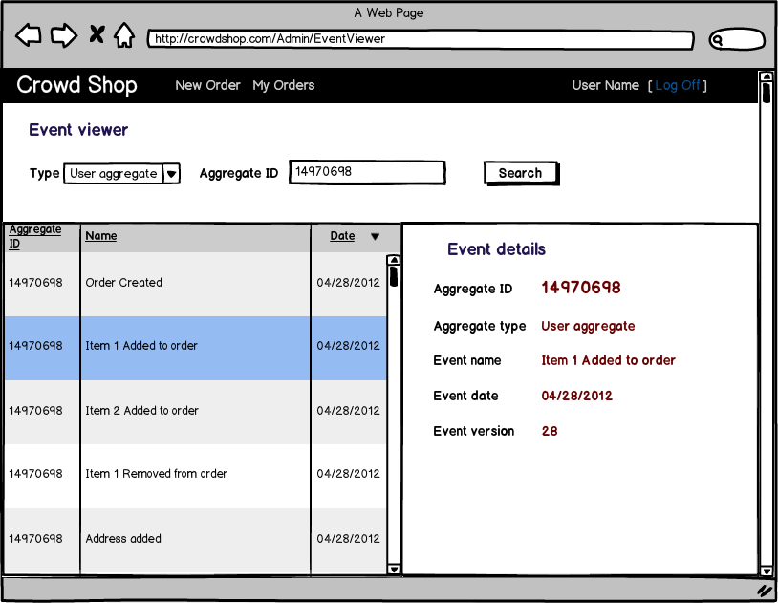

- Find event

Actors:
- Registered user (has an existing account; administrator rights)
- System (returns events with details that have been searched)

Triggers:
- User chooses the aggregate type, enters (in the corresponding field) an aggregate id that she/he wants to find and pushes the Search button.

Preconditions:
- User has logged in.

Post-conditions:
- The list of events will be shown.

Normal Flow:
- User chooses the aggregate type.
- User enters (in the corresponding field) an aggregate id that she/he wants to find.
- User pushes the Search button.
- The system will present the list of events.

- Sort list of events

Actors:
- Registered user (has an existing account; administrator rights)
- System (returns events in required order)

Triggers:
- User clicks on a column header to change the sort order.

Preconditions:
- User has logged in.
- The list contains the set of already found events originally sorted by Date (desc).

Post-conditions:
- The list of events will be shown with required sorting settings with correct visual mark (▼ – descending, ▲ - ascending) in the corresponding header.

Normal Flow:
- User clicks on a column header.
- The list changes its sort settings (field and mode) to the required.

- Display event details

Actors:
- Registered user (has an existing account; administrator rights)
- System (returns event details)

Triggers:
- User clicks on a list item to see event details.

Preconditions:
- User has logged in.
- The list contains the set of already found events.

Post-conditions:
- The right part of the window will contain details for the chosen event.

Normal Flow:
- User clicks on a table row.
- In the right part of the window will be displayed details for the chosen event.

